insideONE, the tactile braille tablet.

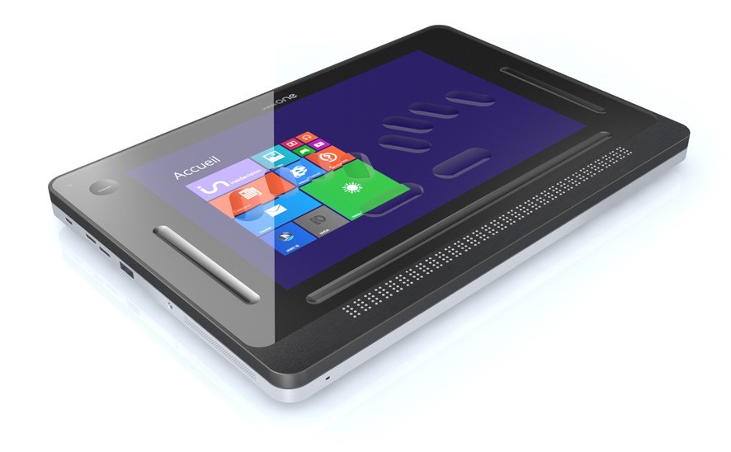

SHORTCUTS & GESTURES

Insidevision – v.1_12_20
Contents

Appendices 3
Appendix A: Bottom Slider 3
Appendix B: Button 5
Appendix C: Left Slider 5
Appendix D: Right Slider 6
Appendix E: Screen (when keyboards are inactive) 7
Appendix F: Braille shortcuts 10
Appendix G: F keys shortcuts 12

Appendices

Appendix A: Bottom Slider

Zone | Action | Home | Windows
Bottom Slider | Swipe right with one finger | pans the display forward | pans a display forward
Bottom Slider | swipe left with one finger | pans the display backward | pans a display backward
Bottom Slider | one-finger double-tap | activates an item under a cursor/moves the cursor | activates an item under a cursor/moves the cursor
Bottom Slider | triple-tap with one finger | highlights a word under a cursor; Highlights an object in a list | None
Bottom Slider | Two-finger single-tap | pauses speech | pauses speech (not with JAWS)
Bottom Slider | Two-finger double-tap | Run menu | Alt
Bottom Slider | Two-fingers triple-tap | Pop menu | Right-click
Bottom Slider | swipe right with two fingers | moves to the next object of different type/to the next word when editing/ | Tab
Bottom Slider | swipe left with two fingers | moves to the previous object of different type/to the previous word when editing/ | Shift+Tab
Bottom Slider | swipe down with two fingers | reads text starting from the current position of the cursor | reads text starting from the current position of the cursor (not with JAWS)
Bottom Slider | swipe up with two fingers | reads the object under the cursor/goes back to the focused object | reads the object under the cursor (not with JAWS)
Bottom Slider | swipe right with two fingers then left | escapes the current menu and goes back to the application you were in/de-selects highlighted text | Escape
Bottom Slider | swipe right with three fingers | moves to the last object of the same type/moves the cursor to the next paragraph | End
Bottom Slider | swipe left with three fingers | moves to the beginning of a paragraph and to the previous paragraph/moves to the first object of the same type | Home
Bottom Slider | swipe down with three fingers | goes to the end of a document | goes to the end of a document
Bottom Slider | swipe up with three fingers | goes to the beginning of a document | goes to the beginning of a document
Bottom Slider | swipe three fingers right then left | cancels the last action | Ctrl+Z
Bottom Slider | swipe three fingers left then right | repeats the last action | Ctrl+Y

Appendix B: Button

Zone | Action | Home | Windows
Button | left or Right swipe with one finger | Alt+Tab switching between any open applications | Alt+Tab switching between any open applications
Button | double-tap | switches between Windows and Home environments | Switches between Windows and Home environments, if Home is installed. If Home is not installed or launched, comes back to Windows desktop or the app you were before
Button | press and hold one finger for five seconds | turns the screen on and off | turns the screen on and off

Appendix C: Left Slider

Zone | Action | Home | Windows
Left Slider | swipe up with one finger | announces a braille grade currently in use | announces a braille grade currently in use
Left Slider | swipe down with one finger | closes all open keyboards | closes all open keyboards
Left Slider | hold one finger for five seconds | activates QWERTY keyboard | activates QWERTY keyboard; enables on-screen gesture in Windows; when JAWS is enabled, use Windows gestures. To switch to JAWS gestures, rotate 5 five fingers on a screen

Appendix D: Right Slider

Zone | Action | Home | Windows
Right Slider | swipe up with one finger | up arrow | up arrow
Right Slider | swipe down with one finger | down arrow | down arrow
Right Slider | swipe left with one finger | Moves to the previous object of the same type/moves to the previous character | left arrow
Right Slider | swipe right with one finger | Moves to the next object of the same type/moves to the next character | right arrow
Right Slider | hold one finger for five seconds | enables/disables text-to-speech | enables/disables text-to-speech (not with JAWS)
Right Slider | double tap with one finger | Selects the highlighted object | Enter
Right slider | Swipe right with two fingers (put one finger above the other) | Moves to the next object of a different type/moves the cursor to the next word | NVDA – JAWS: Tab
Right slider | Swipe left with two fingers (put one finger above the other) | goes to the previous object of a different type/moves the cursor to the previous word | NVDA – JAWS: Shift + tab

Appendix E: Screen (when keyboards are inactive)

Zone | Action | Home | Windows
Screen | Swipe right with one finger | Moves to the next object of the same type/moves to the next character | Right arrow
Screen | swipe left with one finger | Moves to the previous object of the same type/moves to the previous character | Left arrow
Screen | Swipe up with one finger | Up arrow | Up arrow
Screen | Swipe down with one finger | Down arrow | Down arrow
Screen | one-finger double-tap | activates an item under the cursor | activates an item under the cursor
Screen | Two-finger single-tap | pauses speech | pauses speech (not with JAWS)
Screen | Two-finger double-tap | Run menu | Alt
Screen | Two-fingers triple-tap | Pop menu | Right-click
Screen | swipe right with two fingers | moves to the next object of different type/to the next word when editing/ | Tab
Screen | swipe left with two fingers | moves to the previous object of different type/to the previous word | Shift+Tab
Screen | swipe down with two fingers | reads text starting from the current position of the cursor | reads text starting from the current position of the cursor (not with JAWS)
Screen | swipe up with two fingers | Goes back to the focused menu/goes back to the cursor | NVDA reads the current object
Screen | swipe right with two fingers then left | escapes the current menu and goes back to the application you were in/de-selects highlighted text | Escape
Screen | swipe right with three fingers | moves to the last object of the same type/moves the cursor to the next paragraph | End
Screen | swipe three fingers left | moves to the beginning of a paragraph and to the previous paragraph/moves to the first object of the same type | Home
Screen | swipe down with three fingers | goes to the end of a document | goes to the end of a document or Ctrl+End
Screen | swipe up with three fingers | goes to the beginning of a document | goes to the beginning of a document or Ctrl+Home
Screen | swipe three fingers right then left | cancels the last action | Ctrl+Z
Screen | swipe three fingers left then right | repeats the last action | Ctrl+Y
From the outer top of the screen to its outer bottom | swipe down with four fingers | goes to Home desktop | None

Appendix F: Braille shortcuts

Key Name | Dot Combinations
Alt | 2+0
Alt toggle | 1+0
Alt+f4 | 2+5+7+8+9+0
Arrow Down | 4+9+0
Arrow Left | 3+9+0
Arrow Right | 6+9+0
Arrow Up | 1+9+0
Backspace | 7
Begin selection (NVDA only) | 1+2+4+5+9+0
End selection (NVDA only) | 2+3+5+6+9+0
Caps lock toggle | 7+9
Ctrl | 2+5+0
Ctrl toggle | 1+4+0
Ctrl+ Arrow Right | 5+9+0
Ctrl+ Arrow Left | 2+9+0
Ctrl+c | 1+4+9+0
Ctrl+v | 1+2+3+6+8+0
Ctrl+x | 1+3+4+6+9+0
Ctrl+f | 1+2+4+9+0
Ctrl+o | 1+3+5+9+0
Ctrl+s | 2+3+4+9+0
Ctrl+n | 1+3+4+5+9+0
Ctrl+alt+tab | 1+2+3+4+5+6+9+0
Ctrl+home | 1+2+3+9+0
Ctrl+end | 4+5+6+9+0
Date Time (NVDA only) | 1+2+5+9+0
Delete | 1+4+5+9+0
End | 4+5+6+8+9+0
Enter | 8 or 9+0
Escape | 1+5+0
Home | 1+2+3+7+9+0
Insert | 3+5+9+0
Insert toggle | 2+4+9+0
Line break (NVDA only) | 1+2+9+0
Mute Volume toggle | 1+2+3+6+9+0
Media previous track | 2+4+6+0
Media next track | 1+3+5+0
Media play / pause | 1+5+6+0
Median point (dot 8 alone) | 8+0
No breaking space (dot 7 alone) | 7+0
Number lock toggle | 8+9
NVDA Key toggle (NVDA only) | 1+3+4+5+0
Page Up | 1+3+9+0
Page Down | 4+6+9+0
Pause | 1+2+3+4+9
Print Screen | 1+2+3+4+9+0
Reset display (NVDA only) | 1+2+3+5+7+8+9+0
Right click | 1+3+4+9+0
Say battery status (NVDA only) | 1+2+0
Screen Curtain Toggle (NVDA only) | 1+2+3+4+5+6+8+0
Shift | 3+7+5+0
Shift toggle | 2+3+4+0
Shift+Tab | 2+3+4+5+9
Space | 0 or 9
ShowGui (NVDA only) | 1+3+4+5+9
Speech toggle (NVDA only) | 2+3+4+9
Tab | 2+3+4+5+0
Title (NVDA only) | 2+3+4+5+9+0
Toggle Input Help (NVDA only) | 1+2+5+0
Volume Up | 1+2+3+6+0
Volume Down | 1+2+3+6+9
Windows | 3+5+6+8+0
Windows toggle | 2+4+5+6+0
Windows+m | 1+3+4+0
Windows+ + zoom (NVDA only) | 1+3+5+6+0
Windows+ - zoom (NVDA only) | 1+3+5+6+9
Specific shortcut for Home menu | 1+2+5+9+0
Specific shortcut for Home Control menu | 1+4+0 then 1+0 then 1+4

Appendix G: F keys shortcuts

Key Name | Dot Combinations
F1 | 1+9
F2 | 1+2+9
F3 | 1+4+9
F4 | 1+4+5+9
F5 | 1+5+9
F6 | 1+2+4+9
F7 | 1+2+4+5+9
F8 | 1+2+5+9
F9 | 2+4+9
F10 | 2+4+5+9
F11 | 1+3+9
F12 | 1+2+3+9

